### **Brief Documentation for Building and Deploying Pet-Clinic Java Application Using Maven on Ubuntu**

This documentation will guide you through the steps of building and deploying the Pet-Clinic Java application using Maven on an Ubuntu system.

#### **Initial Setup and Cloning the Repository**

* **Update the System:**

sudo apt update

* **Set Hostname:**

You can change the hostname for the server:

sudo hostnamectl set-hostname pet-clinic_java-build

* **Clone the Git Repository:**

Clone the jpetstore-6 repository from GitHub:

git clone <https://github.com/jaiswaladi246/jpetstore-6.git>cd jpetstore-6/

#### **2. Install Required Software**

* **Install Tree for Directory Structure Visualization:**

sudo apt install tree  
tree

* **Install Java Development Kit (JDK) 11:**

Make sure the correct version of Java is installed (JDK 11):

sudo apt install openjdk-11-jdk  
java -version

* **Install Maven:**

To build the project, you need Maven:

sudo apt install maven  
mvn -v

#### **3. Build the Application**

* **Validate Maven Project:**

Validate the project’s structure and dependencies:

mvn validate

* **Package the Application:**

Package the Java application using Maven:

mvn package

The output .war file will be generated in the target/ directory.

#### **4. Install and Set Up Apache Tomcat**

* **Download and Extract Tomcat:**

You need to download and extract Apache Tomcat:

wget <https://dlcdn.apache.org/tomcat/tomcat-9/v9.0.102/bin/apache-tomcat-9.0.102.tar.gz>tar -xvf apache-tomcat-9.0.102.tar.gz  
cd apache-tomcat-9.0.102/

* **Start Tomcat Server:**

Start the Tomcat server:

cd bin  
./startup.sh

* **Verify Tomcat Running:**

You can verify if Tomcat is running by accessing the following URL in your browser:

curl http://<YOUR-TOMCAT-IP>:8080/manager

Replace <YOUR-TOMCAT-IP> with the actual IP of your server.

#### **5. Deploy the Application**

* **Copy the WAR File to Tomcat’s Webapps Directory:**

Copy the .war file into Tomcat’s webapps/ directory to deploy the application:

cp -r ~/jpetstore-6/target/*.war ~/jpetstore-6/target/apache-tomcat-9.0.102/webapps/

* **Verify Deployment:**

Verify that the .war file has been deployed:

ls ~/jpetstore-6/target/apache-tomcat-9.0.102/webapps/

* **Check if the Application is Running:**

Once deployed, you can visit the application in a browser at:

http://<YOUR-TOMCAT-IP>:8080/jpetstore

#### **6. Troubleshooting**

* **Check Tomcat Processes:**

If the Tomcat server isn’t running as expected, check the running processes:

ps -ef | grep tomcat

* **View Tomcat Logs:**

If there are issues with Tomcat or the application, check the logs in the logs/ directory inside Tomcat:

cd ~/jpetstore-6/target/apache-tomcat-9.0.102/logs/  
cat catalina.out

**Final OutPut:**

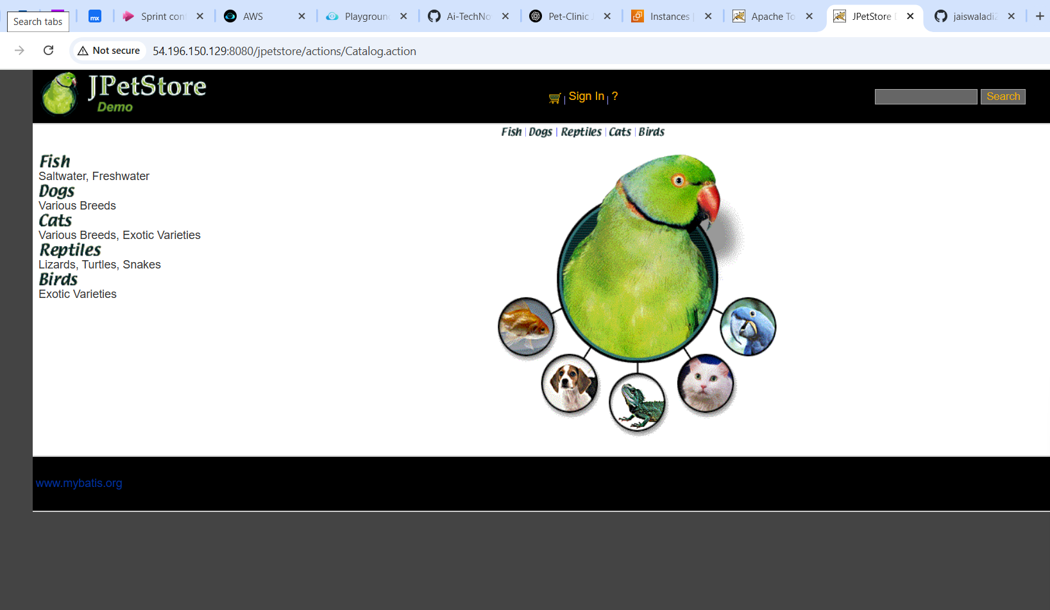

### **Conclusion**

This process successfully builds and deploys the Pet-Clinic application using Java, Maven, and Apache Tomcat on an Ubuntu system. Following these steps ensures that you have all the required tools installed and that the application is running smoothly on the server.